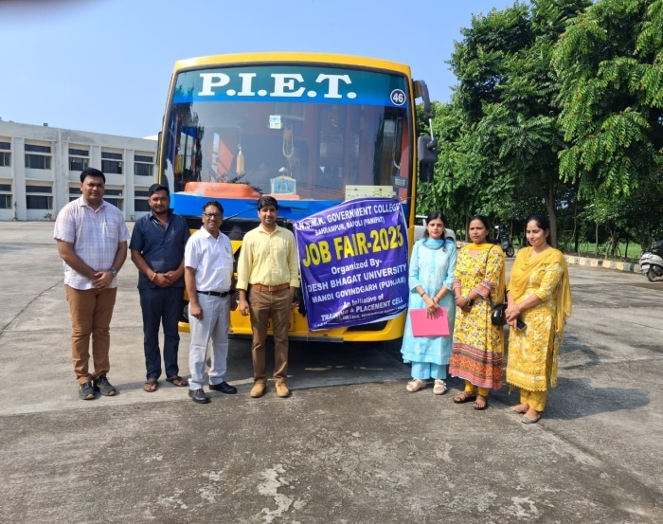 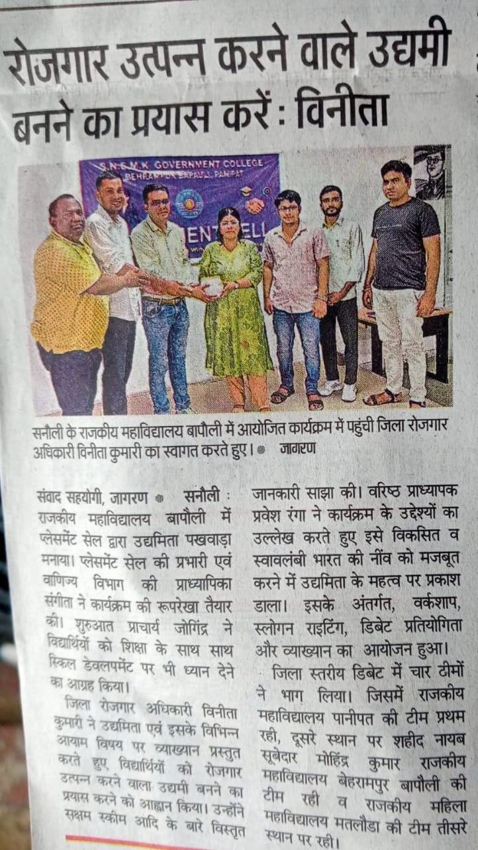

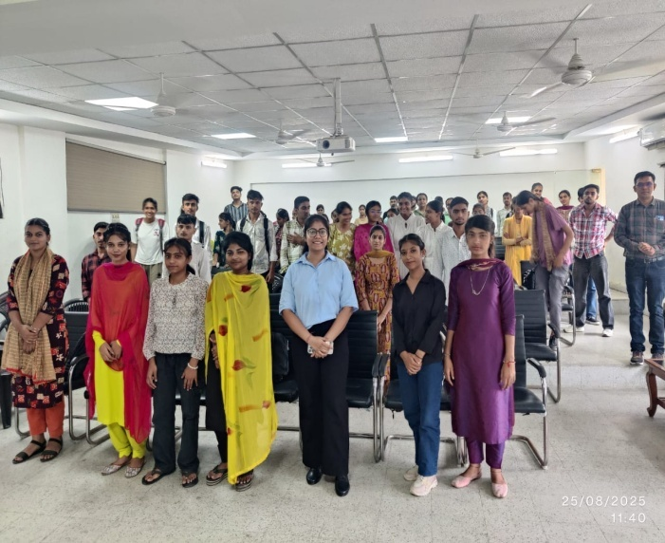 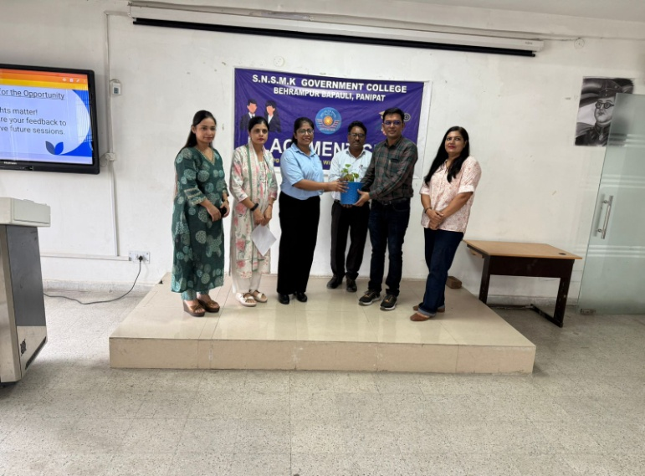

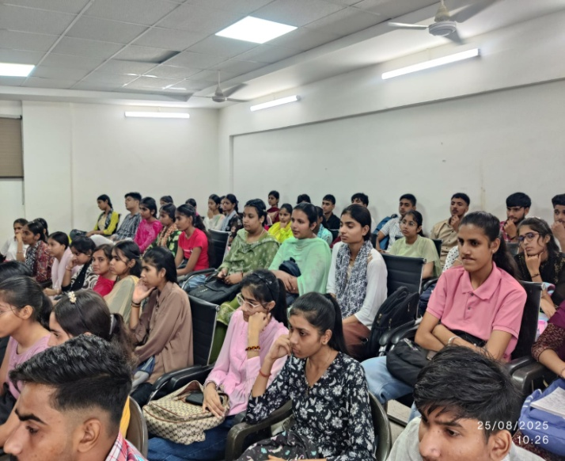 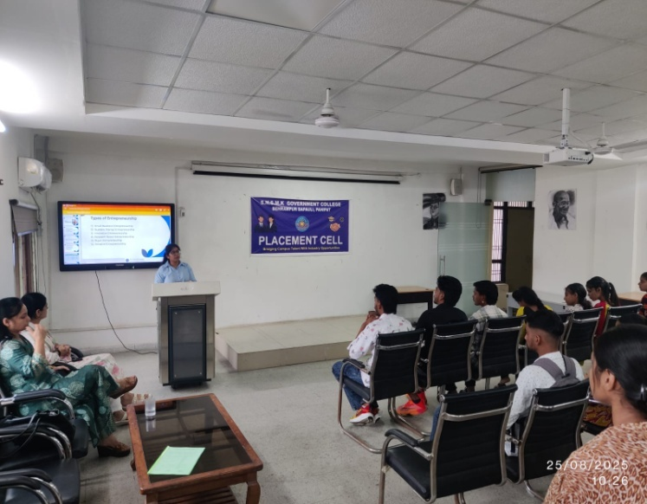

Day 1

: On World Entrepreneurship Day, the Placement Cell, in collaboration with the Employment Office Panipat, conducted a workshop on Entrepreneurship to encourage innovation and self-employment.

: Here's a glimpse into a day filled with innovation, ideas, and inspiration!

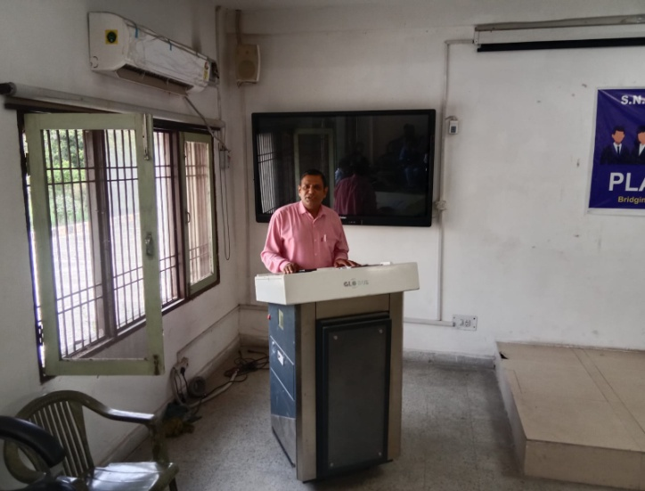 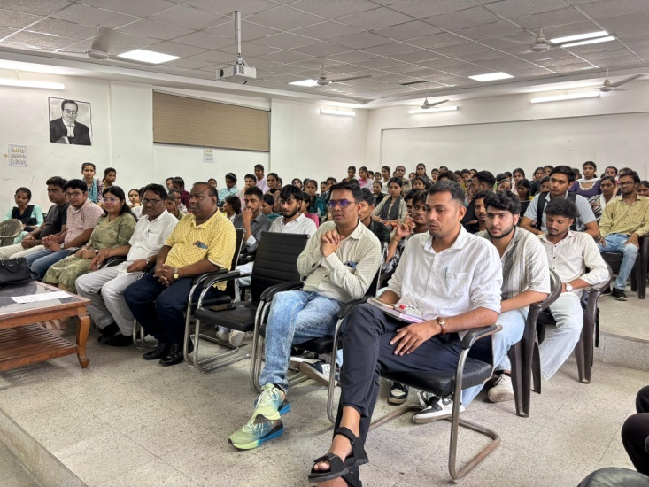

: Day 2

: On the occasion of Entrepreneurship Pakhwada, An Inter-College Debate Competition was successfully organized, followed by a Prize Distribution Ceremony recognizing winners of the Debate, Idea Generation, and Slogan Writing Competitions - providing a platform to nurture creativity, critical thinking and entrepreneurial potential among students

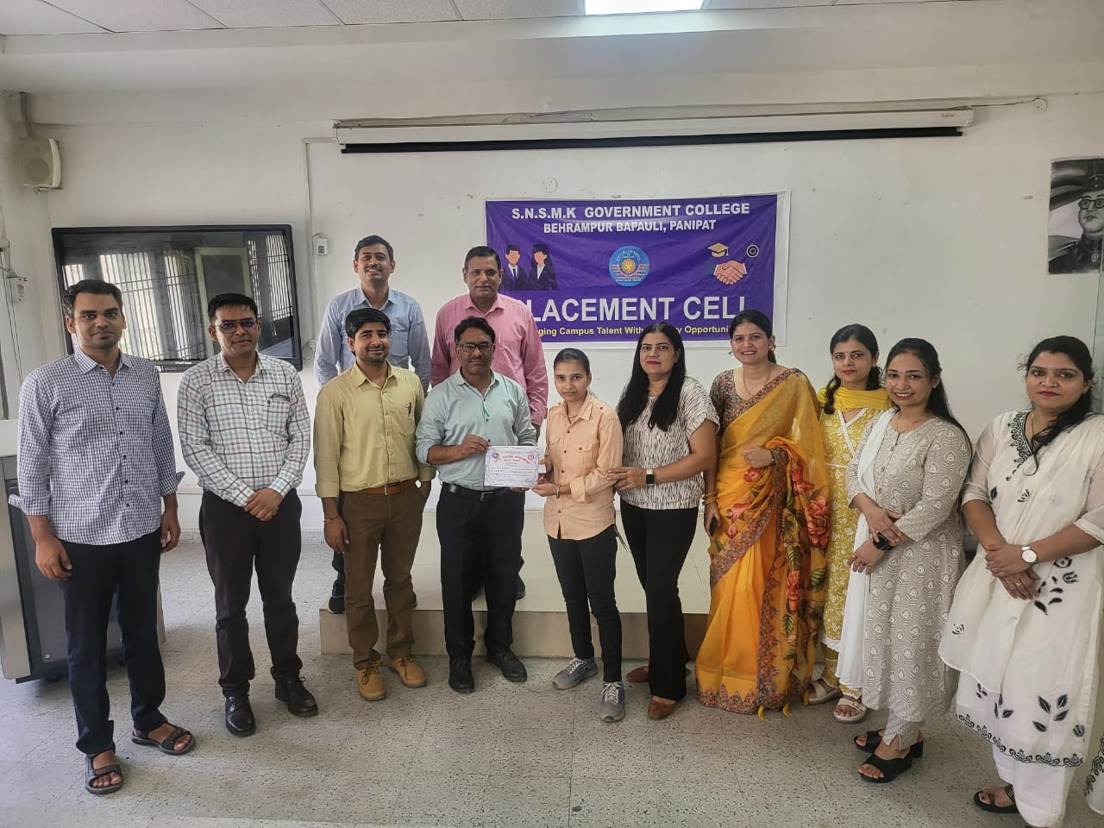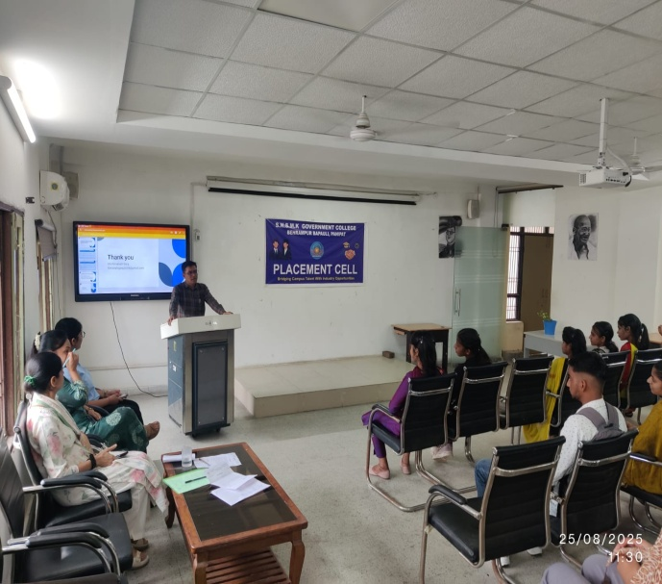

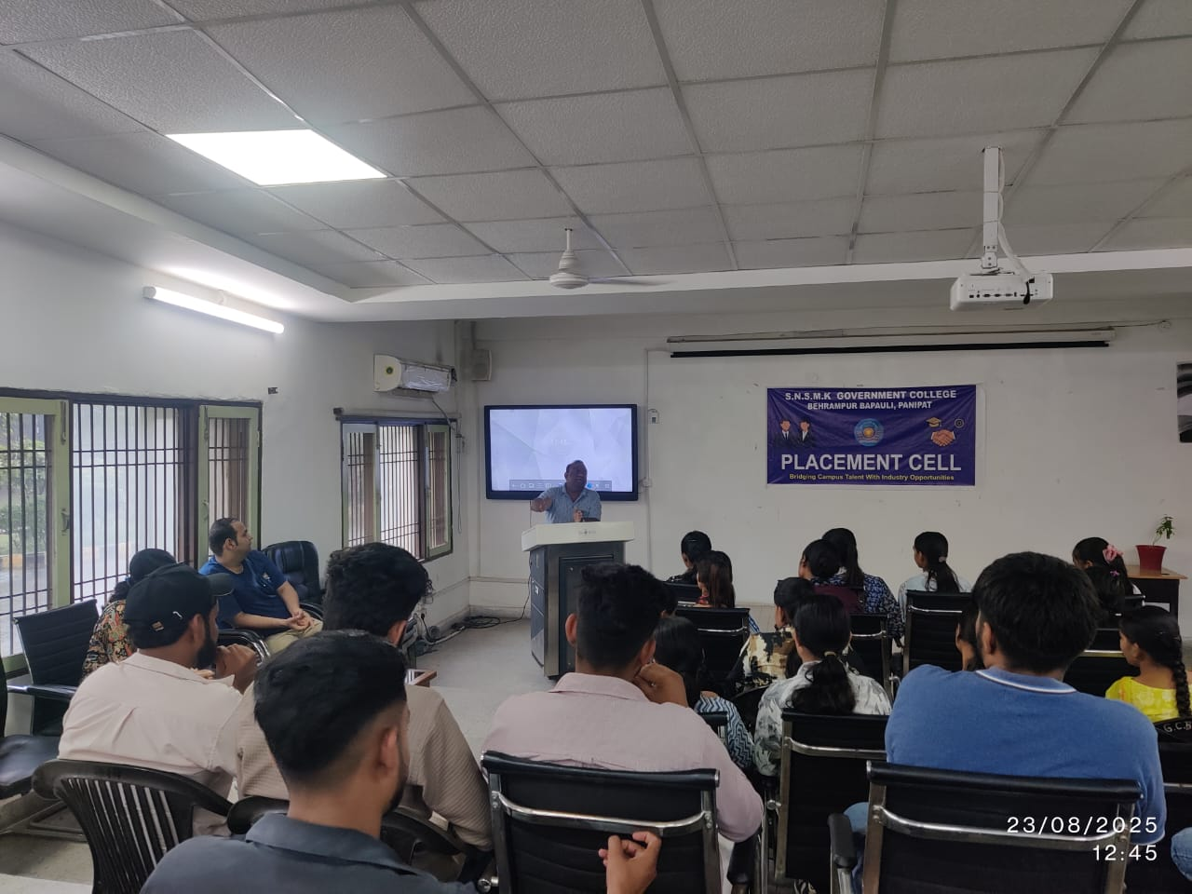 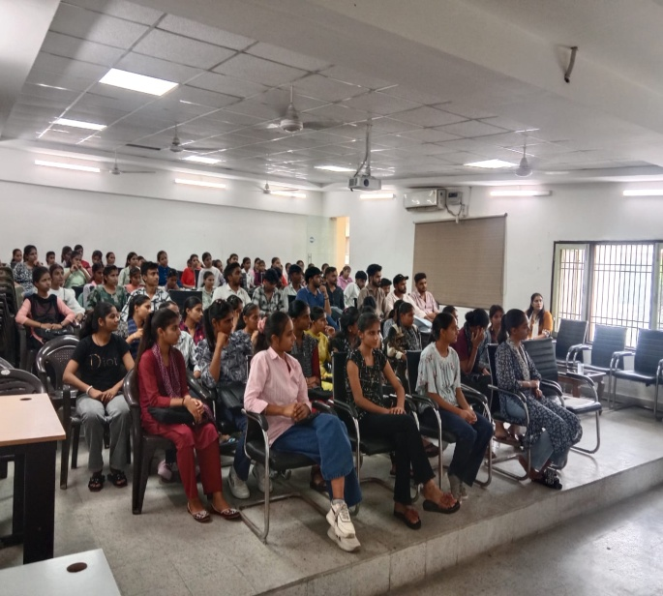

Day 3

: Insightful glimpses from enriching sessions by Mr Paras Batra (Assistant Professor, Department of Business studies, Piet, Panipat, Haryana) on “Entrepreneurial Success Stories” and “Entrepreneurship in the Industrial Revolution 4.0 Stage” under placement cell that inspired innovation, leadership, and entrepreneurial thinking among our students.

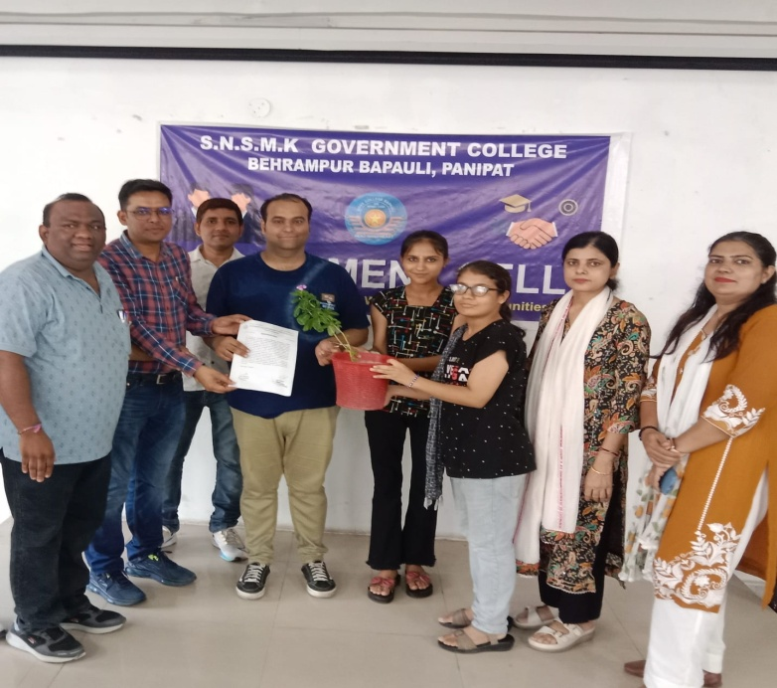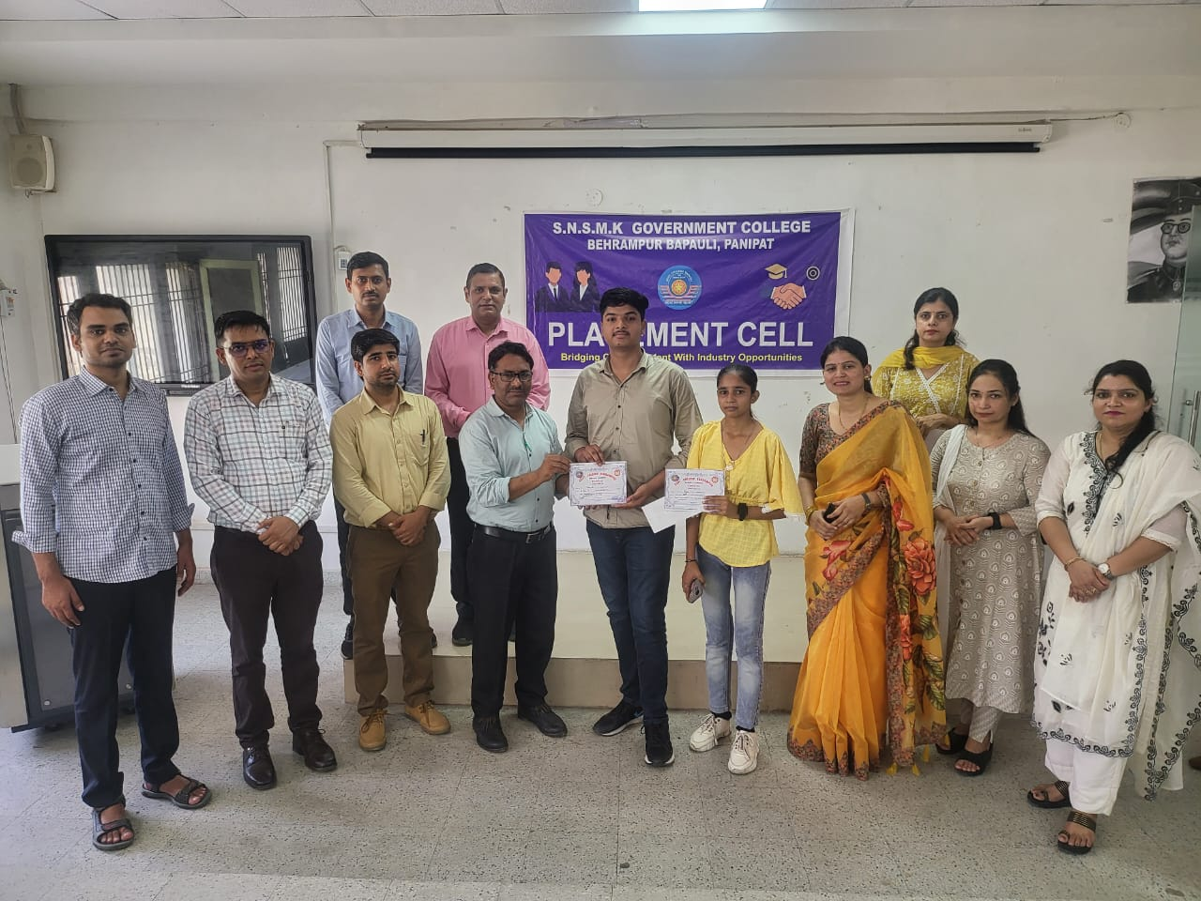

Day 4

: On the concluding day of Entrepreneurship Pakhwada, we were privileged to host Ms. Himanshi Garg (C.A.) from J.J. DECOR – Manufacturers & Exporters of Export Quality Handloom Goods, Panipat, Haryana.

Her insightful interaction offered students a deeper understanding of real-world entrepreneurship and the handloom export industry.

